Example projects for 02561 Computer Graphics

# Project example 1: Voxel world

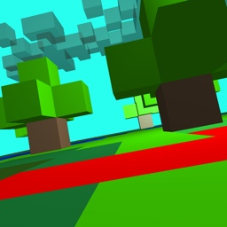**Description:** Create a voxel world (like Minecraft) either procedural or by loading voxel positions from a file. The user should be able to navigate through the voxel world and look around (collisions with voxels should not be considered).

The voxel world should have a light source and use either a diffuse shader or a diffuse + specular shader to render the voxels.

**Possible extensions:**

* Adding textures to voxels.
* Adding a skybox to the scene.
* Creating an edit mode where the user can add and remove voxels (use the SelectBuffer to get the selected voxels).
* Support transparent textures.
* Create collisions and jump mechanics (Hard!).

# Project example 2: Terrain generation

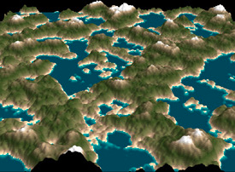**Description:** Create a large triangular mesh where the vertices in the X and Z direction are regularly distributed and the height of each vertex is computed using a Perlin noise function.

The color of each vertex should depend on the height (below 0 should be blue, around 0 should be sand and above 0 should be green).

The scene should be rendered using a diffuse shader and a directional light source.

The user should be able to fly over the terrain and look around.

**Possible extensions:**

* The computation of the height value and the color can also be done in the vertex shader
* Instead of colors for each vertex, you could use textures and blend the two closest surface materials

# Project example 3: Snake game

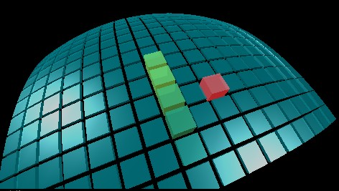**Description:** Create a simple snake game, where the player controls the snake movement. The purpose of the snake game is to eat ‘food’ pieces, which appears at random locations.

The game play is in 2D but the scene is created in 3D.

**Possible extensions:**

* Multiplayer (two or more players on same computer)
* Add score to game
* Animate the color of the food

# Project example 4: 2D text support

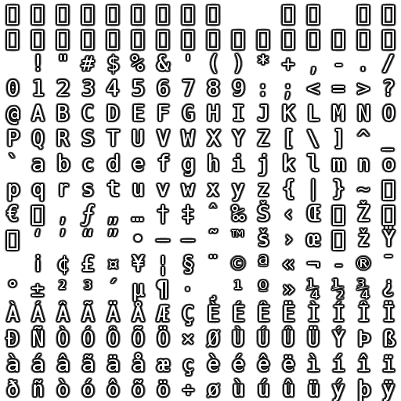**Description:** OpenGL does not have support for text. Create a function that shows a text in windows coordinates. The function should create and draw a mesh that for each letter in the word creates two triangles that uses the UV of the letter in the texture.

The function should have the following signature:

drawText(vec2 position, string text).

**Possible extensions:**

* Create another function that draws text in world space.
* Add support for newline character to create line breaks
* Create a scene with letter blocks (as picture below)

